float temp;
int tempPin = 0;

void setup() {
Serial.begin(9600);
}

void loop() {
temp = analogRead(tempPin);
temp = temp * 0.48828125;

Serial.print("TEMPERATURE = ");
Serial.print(temp);
Serial.print("*C");
Serial.println();

delay(1000);
}

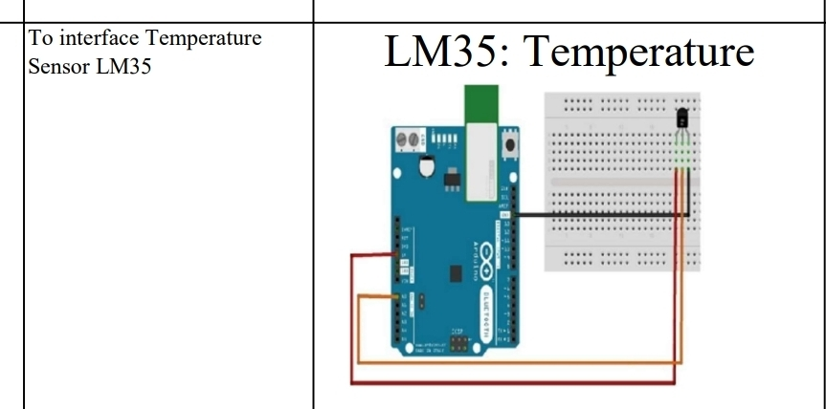

Connections:
Pin Connection
Left VCC (5V)
Middle Output → A0
Right GND

